eCode
User’s Manual

1 Installation 3
2 Stroke and Stroke Order Mapping 5
2.1 Things to Watch out 6
2.1.1 「冖」mapping 7
2.1.2 「丶」usage 7
2.1.3 「ꀊ」Radical 8
2.1.4 Open Mouth characters 8
2.1.5 匚 type characters 9
2.1.6 Miscellaneous 9
3 Installing License 10
4 Using ECODE 10
4.1 Stopping ECODE 11
4.2 Selecting Chinese word with ECODE 11
4.3 Inputting Chinese 12
4.4 Wildcards 12
4.5 Punctuations and Brackets 12
4.6 Shortcuts 13
4.7 ECODE MENU 14
4.8 Search/Customize 14
4.9 Match Button 15
4.10 Search Button 16
4.11 Customize 17
4.11.1 Customizing a word 17
4.11.2 Removing a Customization 18
4.11.3 Customizing a group of words 19
4.11.4 Follow Stroke Checkbox 21
4.12 Select Code Menu 21
4.13 Mode 22
4.14 Font 22
4.15 Install License 23
4.16 Help 23
4.17 Language 24
4.18 Pinyin 24
4.19 Pronounce 24
4.20 Companion Word 24
4.21 Shift Key 25
4.22 Exit 26

Installation

Put the CD in the CD ROM. The following eCode setup screen should automatically be displayed.

Make sure you have closed all eCode applications if you are doing a reinstallation.

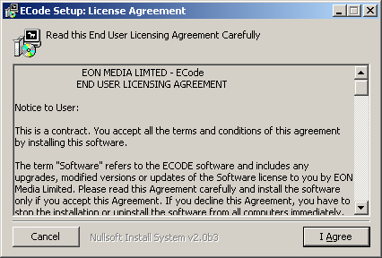

Please read the End User Licensing Agreement carefully. If you do not accept the agreement, please select CANCEL and terminate the installation immediately. You are deemed to have accepted the agreement if you proceed with the installation.

Select “I Agree” if you accept the Licensing Agreement.
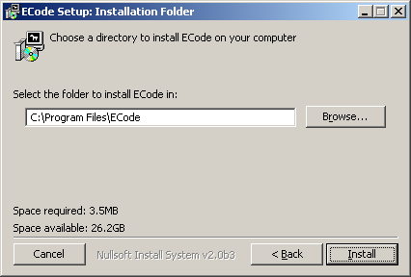

The default installation directory is as shown. You can change the eCode installation directory if you intend to install it somewhere else. Make the appropriate change if any and select “Install” to install eCode.

Make sure that you have write permission to the selected installation directory.

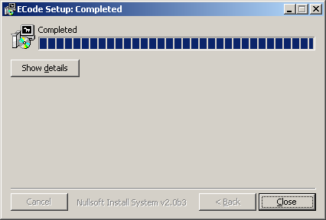

The above screen will be displayed once eCode has finished installation.
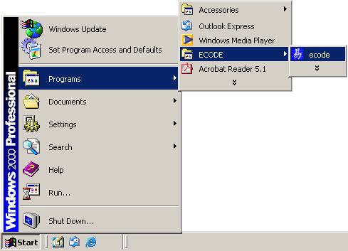

Go to the START Menu. There should be a ECODE item. Select eCode to start the application.

If you are starting eCode for the very first time, you will be granted a 30 days evaluation license.

Please do not adjust the time in any manner to try to counter this check, as this will disable eCode immediately.

Stroke and Stroke Order Mapping

Chinese characters are composed of stroke and stroke orders written in a certain order. There are more than 7 basic strokes and they are generally oriented as follows

- Horizontally
- Vertically
- Left slanting
- Right slanting
- Bend, twist and hooks

eCode represents all these strokes with 7 basic types as depicted in the following diagrams.

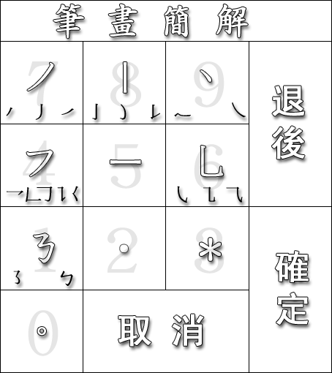

The mapping of Chinese strokes to eCode 7 basic strokes should be very intuitive and is also depicted in the diagram above. In general, this mapping is based largely on stroke orientation. Vertically oriented strokes such as「亅」，「ꀁ」or 「ꀂ」are mapped to「丨」 or Numeric Key 8 and left slanting oriented strokes are a mapped to Numeric Key 7 and so on.

Things to Watch out

Assuming for the time being that we are clear about the rules of Chinese writing and are able to write Chinese with the correct stroke order, we will have no problem recalling a great majority of Chinese characters from simple character such 「王」to complex character such as「灩」.

In reality, some characters mapping can be rather ambiguous and we need to make it clear in this section how those characters are mapped in eCode.

「冖」mapping

「冖」is mapped to 「丿乛」. Note that we mapped the first stroke to「丿」not「丨」as it is sometime written. Examples of affected characters are 「家，骨，雪」.

Even though eCode can have more than one mapping and we can easily map all affected characters to「丨乛」as well, we decided against this for the following reasons

- This will make the mapping database unnecessarily bigger.
- This will introduce more matches to the same key sequence

「丶」usage

Contrast the radical「爫」and 「ꀃ」. Both represent the same radical but the left slanting stroke in one can become the right slanting stroke in the other. As such we have very often simply represent both left slanting and right slanting strokes using 「丶」 as 「丿丶丶丶」 in this case.

We have also use「丶」to encode the following characters or radicals

ꀄ | 丿丶丶丿丶丶
习 | 乛丶丶
爫 | 丿丶丶丶
冬 | 丿乛丶丶丶
兆 | 丿丶丶乚丶丶
疒 | 丶一丿丶丶
忄 | 丨丶丶

Note that for the radicals ， 「冫」 and「氵」， we have actually encoded them as 「丶丿」 and 「丶丶丿」respectively. These radicals often form the beginning strokes of many characters. Encoding them as such reduce the number of matches significantly.

「ꀀ」Radical

We have encoded all 「ꀀ」as 「艹」 or 一丨丨. This is depicted in the following table.

草 | 一丨丨乛一一一丨
獲 | 丿丨丿一丨丨丿丨丶一一一丨一乛丶
華 | 一丨丨一一丨丨一一丨
ꀅ | 一丨一丨丨丨乛一一一丿丶
ꀆ | 丿一一丨丨一丨一

Open Mouth characters

There are several characters that appear to have the 「口」portion broken into two halves. Examples of these characters are 「亞斲丣戼」. It is often confusing to enter these characters via their correct strokes, as we need to figure out whether the next stroke should be 「一」， 「丨」，「乛」，「ㄥ」or 「ㄅ」.

It is far easier to simply think of the 「口」portion as closed and encode them as such. The character 「亞」will be encoded as 「亜」as depicted in the following table.

亞（亜） | 一丨乛一丨丨一
斲（ꀇ） | 丨乛一丨乛一丨丨一丿丿一丨
丣（ꀈ） | 一丨乛一丿丨
戼（ꀈ） | 一丨乛一丿丨

ECode also provides the correct stroke mapping for these characters. The character 「亞」, for example, can also be retrieved with 「一丨一ㄅㄅ一丨一」. However, as the task at hand is to retrieve the character efficiently, it will be far easier to retrieve ”open mouth” characters assuming the mouth is closed.

匚 type characters

Sample characters belonging to the 「匚」 type are 「医区區」. The correct stroke order for this class of the character is normally as follows

- Top horizontal stroke, 「一」, first
- Internal part next as in 「失乂 or 品」
- Enclosing stroke, 「ꀌ」 last

There are two exceptions to the above rule for 「巨」 and 「臣」 characters. In these two cases, the internal part needs something to lean on so these characters are written as

- Top horizontal stroke, 「一」, first.
- Left vertical stroke 「丨」next
- Internal part follows as in 「ꀉ or ꀊ」
- Bottom horizontal stroke, 「一」, last.

This is summarized in the following table

医 | 一丿一一丿丶乛
区 | 一丿丶乛
區 | 一丨乛一丨乛一丨乛一乛
巨 | 一丨乛一一
臣 | 一丨丨乛一丨一

Miscellaneous

The users may also like to take note of the stroke orders for the following characters and words deriving from them

匕 | 丿乚 Internal 「丿」 first. Examples of other words are  比「一丨丿乚」 or 「丿乚丿乚」  死「一丿乛丶丿乚」  北「丨一一丿乚」  能「乛丶丨乛一一丿乚丿乚」
火 | 丶丿丿丶 Note encoding
凶 | 丿丶乛丨 Internal 「乂」 followed by enclosing 「凵」  凷「一丨一乛丨」  齒「丨一丨一丿丶丿丶一丿丶丿丶乛丨」
ꀋ | 丨丶丿 Middle vertical stroke first  光「丨丶丿一丿乚」  常「丨丶丿丿乛丨乛一丨乛丨」  當「丨丶丿丿乛丨乛一丨乛一丨一」

Installing License

If you have purchased the eCode CD, you can find the Serial Number on the CD cover. If you have purchased ECODE over the Web, you will receive the Serial Number via Email.
The eCode serial number is a 24-digit number broken into a 4 groups of 6 number each.

Move to the top left corner of the eCode Application and click the RIGHT or LEFT mouse.

A menu should pop up as shown in the following diagram.
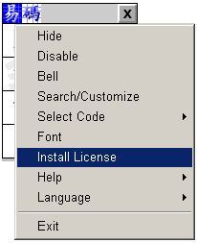

Select “Install License”, the following screen should pop up.

Enter the 24-digit Serial Number and press “OK”. A permanent license should be automatically generated.

Using ECODE

Starting ECODE

START->eCode->eCode

Stopping ECODE

Select the ECODE menu by clicking the top left corner of the ECODE application, select EXIT.

Alternatively, click the top left corner of ECODE application in the x area.

Selecting Chinese word with ECODE

You can use the mouse or the numeric keypad. We highly recommend using the numeric keypad, as it is very fast to enter Chinese that way.

Ensure that the NUMLOCK is ON if you are using the numeric keypad.

Now enter the keystroke corresponding to the appropriate Chinese character. For example, to enter 土, you enter the following key sequences 一丨一.

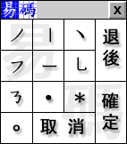
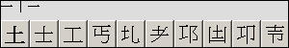

eCode will display a list of 10 Chinese words that match the key sequences. The words are sorted according to the number of strokes. Words with fewer keystrokes will be displayed first.

You can select the required word with by left clicking the mouse button on the word or using the left or right arrow and then using the SPACE or ENTER key to select the word. You can also use up and down arrow or Page up or Page Down keys to scroll through the list.

Please note that the list returned from the above match may not be complete for partial matches. Use the Customize menu to see the complete list.

Inputting Chinese

Open the application that you want to enter Chinese. This can be any application that accepts keyboard input. Examples are Microsoft Word, NotePad, Internet Explorer, Outlook Express or Photoshop etc.

Place the focus on the appropriate area by moving the mouse to the area and click the LEFT mouse button.

Now select the appropriate Chinese word as describe in the last session and press ENTER. The word should be displayed on the selected application.

Wildcards

There are two wildcards, ＊ and • that can be used to search for Chinese character where we only remember part of it.

＊ wildcard matches one or more stroke and
• matches exactly one stroke.

For example, if we only remember that the character, 「憐」 starts with 忄and ends with 舛, we can try to match it with the following keys sequence 丨丶丶＊丿乛丶一乛丨. You can even try to match it with less input using the first and last 3 strokes as in 丨丶丶＊一乛丨.

Tips – As we are displaying only 10 matches and ordered with fewer strokes first, we can use the •wildcard to fill in the middle to eliminate non-matching character with fewer strokes. The above character can be matched using 丨丶丶•••＊一乛丨. This will restrict the match to Chinese characters with 10 strokes or more.

This feature is especially useful when used together with the Customize menu.

Punctuations and Brackets

Punctuations such as。，！「」（）﹖are selected using

- RIGHT mouse button or
- NUMERIC keyboard with ALT or CTRL (W2k only) key pressed.

The following table shows how the punctuations and brackets are coded

。○● | ， | 、 | “ | ”
。 | 丿 | 丶 | 丶丶 | 丿丿
「」〈〉〔〕＜＞ | 《》︿﹀﹁﹂ | 『』︽︾ | （）｛｝【】 | ︵︶︷︸︻︼₣₪
乛 | 乛乛 | 乛乛乛 | 乚 | 乚乚
〜〰＆ | ＊ | • | ： | … ∴ ∵
ㄋ | ＊ | • | •• | •••
； | ※ | ／╭╯ | ＼╮╰ | ₡
•丿 | 丿丶•••• | 丿 | 丶 | 。丿丿
‾ | §©₢℃®＠◎ | ㊣ | ％ | ‰
一 | 。。 | 。一丨一丨一 | 。丿。 | 。丿。。
℉₠ |  | ◆◇ | ◣ | △▲
。乛 | 一丨乛乛 | 丿丶丶丿 | 丨一丶 | 丿丶一
─▔ | ■ | ▼▽ | ╘╒╞╧ | ╤╡╕〒╛
一 | 丨乛一 | 一丶丿 | 丨一一 | 一一丨
╣╦╬﹟＃ | †┐┥┬┼┿㆜＋ | ▁▂▃▄▅▅▇ | ▏▎▍▌▋▋▋ | ★☆
一一丨丨 | 一丨 | 一(一一一一一) | 丨丨丨丨丨) | 乛乛乛乛乛
㆓＝ | ≡﹉﹍

Shortcuts

。丶丶 雨 as in雪需
。丶乚 鼠
。丿丨 鳥鼻
。乚丨 黽龜
。丨乚 黽龜
。乚一 龍
。乛乛 龠
。一一 言隹
。丿丶 麥
。一ㄅ 與
。一丨 車臣走革長
。乛丶 癶馬
。丿乛 鱼魚
。丨丶 黑
。一丶 黃
。一乛 鼓
。一丿 頁
。丨乛 門骨
。丨一 鹵齒
。ㄋ一 鼎
。乛丨 韋
。丶丿 金
。丨丿 麻
。丿乚 風鬲
。乛丿 齊
。丶乛 飠食
。丿丿 舟豕

ECODE MENU

HIDE In this mode, the eCode application screen will disappear the screen. This will minimize the screen area. You can still enter Chinese character using the Numeric keyboard.

DISABLE – In this mode, the eCode application will disappear from the screen and you cannot enter Chinese character after that. You can enable eCode by selecting the Disable Menu again.

BELL – Normally, if you enter a keystroke and there is no word associated with the resulting key sequence, a BELL will sound. You can disable the BELL by selecting this menu.

Search/Customize

This menu enables you to search for all Chinese characters with partial specifications. Wildcards as described above can be use to search for words.

When Search/Customize is selected, the following window will appear.

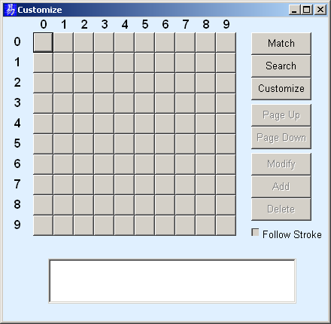

Keystrokes can be entered as before, i.e. either via the Mouse or Numeric keyboard.

Match Button

To search for all words beginning with say, 一丨一, simply enter the keystrokes and select the Match button. All words matching the keystrokes will be displayed as shown below.

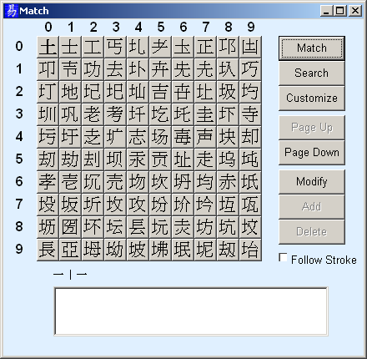

You can use Page Up/Page Down to scroll through the match list.

Search Button

The Search button can be used to search for Chinese characters containing a specified keystrokes sequence anywhere. As before, you simply enter the keystrokes and select the Search Button. The following window shows all Chinese characters containing the 一丨一 sequence.

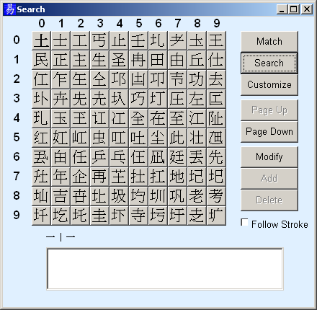

Customize

Users can customize their own keystrokes for a particular word or group of words. The first step to customization is to retrieve the word using either the Search or Match feature.

Customizing a word

Once you have located the word using the Search or Match feature, simply click on the word with the mouse. The word with its corresponding keystrokes will be shown. In the following example, we want to customize the keystroke for the word「老」.

- First, we retrieve the word by entering the following sequence,「一丨一丿丿乚」, and using Match to retrieve a list of words matching the description.
- We select「老」using the mouse.
- We then enter our keystrokes, 「一丨一丿乚丿」 to customize the word.
- Finally, we use the Add Button to add the keystrokes to the word.

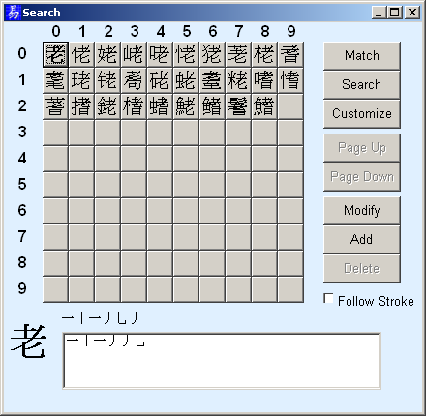

Following the Add, 「老」can be retrieved with both the old and new keystrokes.

Removing a Customization

Using the「老」example, retrieve the word as before. Note that there are now two keystrokes definitions on the list box.

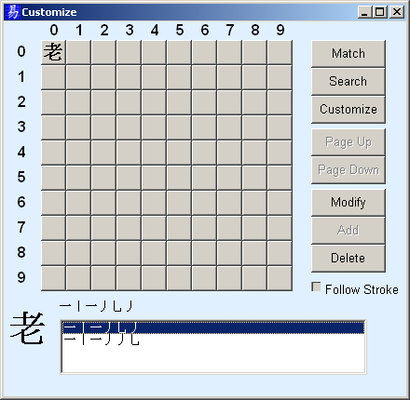

Now, double-click the appropriate keystrokes with the mouse and select the Delete button.

Note:

- You cannot select keystrokes sequences that are originally defined.
- In the Customize mode as indicated on the title, only those Chinese characters that you have defined will be shown.

Customizing a group of words

Supposed we wants to append another our own definitions to all Chinese character containing the word「老」 instead of just the word itself. We can do this as follows.

- Enter the keystrokes for「老」and use the Search Button to retrieve all words containing「老」.
- Go through the list to ensure that every word on the list is as intended. You can delete unintended matches by pressing down the Ctrl key and selecting the word with the mouse.
- Now select the Modify Button.
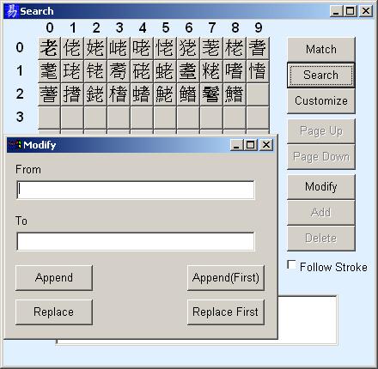

On the Modify Dialog Box, you can enter two keystroke sequences

- The keystroke sequences that is currently defined.
- The keystroke sequences you want to substitute to.

The Append button appends the new definition to the list while the Replace button replace the existing definition with the new one. Note that you cannot replace the original definitions.

The Append (First) and Replace First buttons is similar to the Append and Replace except that it replaces only the first matches.

For example, we may want to replace the first 「土」 in the word 「垚」using the sequence 「丿丨一」 instead of 「 一丨一」. This may not make much sense and its presence here is solely for the purpose of illustration. This can be done as illustrated in the following screen using the Replace First button instead of the Replace button.

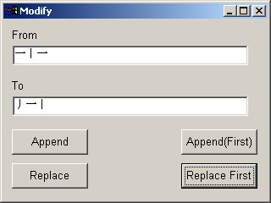

Follow Stroke Checkbox

The Follow Stroke Checkbox is only enabled on the Match or Search mode. If the Follow Stroke is checked, the matches will be updated whenever you enter or remove a keystroke.

Please note that performance may suffer in this mode especially when only one or two keystrokes have been entered. This is due to many matches return when few strokes have been entered.

Select Code Menu

Although eCode works preliminary with UNICODE, user can select amongst the following codes

- Unicode
- Traditional/Simplified
- Traditional
- Simplified

The Unicode code set contains a lot more character that are currently defined in the Traditional Chinese (BIG5) and Simplified Chinese (GB2312) code sets combined. There are some Unicode characters that do not have either a Traditional Chinese or Simplified Chinese mapping.

- In the Unicode mode, all characters are displayed.
- In the Traditional/Simplified mode, only those characters that have Traditional or Simplified Chinese mappings will be displayed
- In the Traditional Chinese mode, only Traditional Chinese characters will be displayed.
- In the Simplified Chinese mode, only Simplified Chinese character will be displayed.

Mode

The Mode menu should be seldom used. It is applicable only to Web developer writing raw HTML or Java code using an editor such as Notepad.

If you want to enter a Chinese character in HTML, you need to provide the Unicode equivalent. For example, to enter the character 「易」, we need to enter &#26131;

This can be very tedious, as we need to figure out the decimal equivalent of the Unicode value for 「易」 and then enter the HTML representation. With eCode, this problem is easily solved simply by setting the mode to HTML using eCode menu. The resulting output should be in the HTML form.

Likewise, if you are writing JavaScript, you will need to enter \u6613 for 「易」. Once again, a translation from a character to its hexadecimal Unicode equivalent is required. eCode solve this problem simply by setting the mode to JavaScript. eCode will then output the character in JavaScript representation.

Font

eCode needs a Chinese font to display correctly. When eCode starts up, it will attempt to select a font from a list of known Chinese fonts. On Chinese versions of Windows, there should be no problem finding a Chinese font to use.

The English version of Windows does not normally come with a Chinese font. One needs to be downloaded from the Internet first before eCode will display Chinese correctly. Typically fonts that support Chinese are

- MingLiU
- SimSun
- MS Song
- MS Hei
- Bitstream Cyberbit CJK

The MingLiU font is automatically downloaded when you try to display a Chinese page on the Internet.

If eCode is not displaying Chinese correctly and you have a Chinese Font, select the Font menu to change the display Font. The following Font dialog will appear.

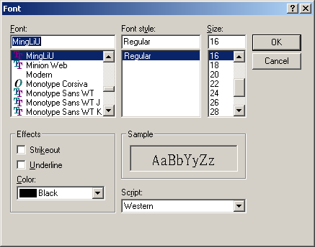

Select the appropriate Chinese Font and check the display again. eCode should be displaying Chinese correctly now.

Once a font is selected, eCode will use the selected Font the next time it starts up.

If you find that you do not like the look of the current font, you can use the Font menu to select a more ecstatically pleasing font.

Install License

This menu will only appear if you do not have a permanent license. Use this menu to install one of the following categories of license

- 3 months Evaluation
- 6 months Evaluation
- 9 months Evaluation
- 12 month Evaluation
- Permanent License.

Help

This menu contains some useful tips.

Language

This menu is only available on Windows 2000 version. On Windows 98 and ME, the Language will default to that of the Windows version.
Select the appropriate display language from the Menu.

Pinyin

Select this Menu if you want Pinyin Input. If enabled, the Pinyin Menu will be checked.

The normal alphabetical character can be used to specify the Chinese characters. In Pinyin, some characters use the Pinyin, Ü character. The Ü character can be entered by holding down the CTRL key and ‘U’ at the same time.

Note that when Pinyin is enabled, all alphabetical character will be directed to eCode.

Pronounce

Ensure that the Pronounce Menu is checked to use this feature. The Speech module is only in a beta stage. We are currently working with a University in China to ensure the correctness of the pronunciation. As it is, the current beta version is not complete and has not been verified for correctness as well.

Nonetheless, it should give you a preview of eCode potential capabilities. To turn on the speech, you will need the following

- Download the speech module and install it in the same directory as eCode.
- Turn the Pronunciation on by selecting Pronounce from the menu.
- As you enter a Chinese character, the character will be pronounced.
- You can tab through the various pronunciations for a character when the character is selected.

Companion Word

Ensure that the Companion Word Menu is checked to use this feature. This is still an incomplete module. The idea here is that many Chinese characters come in pairs and if we forget how to write one character, we can use the companion character to recall the other.

There are other alternatives within eCode to recall characters namely

- Pinyin
- Wildcards

Pinyin is useful when you know how to pronounce the character but have somehow forgotten how to write it. If you are not familiar with Pinyin, you can perform the following to retrieve the required character.

- Simply key in another character with the same pronunciation,
- Use the Shift to recall the Pinyin
- Key in the Pinyin to retrieve the required character.

Wildcards as indicated previously is very useful when you remember part of the character. Simply key in the part that you remember and use wildcards for the part you forget.

Additional development in the pipeline is to use English to retrieve the Chinese equivalent, e.g. entering apple to retrieve 「蘋果」

Shift Key

Pressing the Shift key when a Chinese character is selected provides the following additional information about the character

- Traditional/Simplified Variant if any
- Equivalent characters if any.
- Unicode
- Pinyin
- English meaning

This is illustrated in the following diagram.

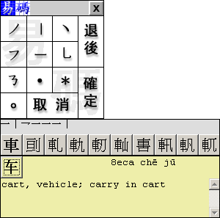

When the Shift key is pressed while the character 「車」is selected, the following additional information is shown

- The simplified form 「车」is shown.
- Unicode, 8eca,
- Pinyin, che and ju and
- English meaning, cart, vehicle; carry in cart.

The alternate form can be entered in the document simply by keeping the Shift key press and pressing Enter.

If there are more than one alternate character, the navigation keys, left arrow and right arrow, can be used to navigate through the alternate characters.

Exit

This is self-explanatory.

